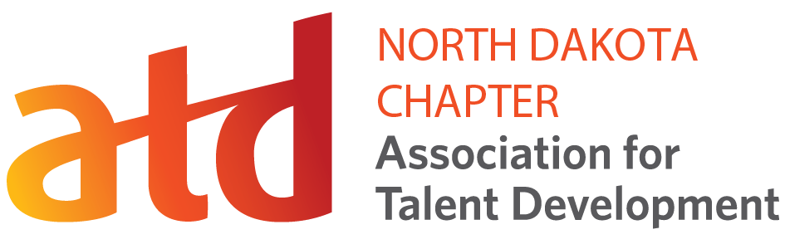
PRESENTATION PROPOSAL FORM

PROPOSED PRESENTATION
Title of Presentation:

Presenter Name(s):

Presenter Title:

Presenter Company:

Presenter Mailing Address:

Presenter E-mail Address:

Presenter website:

Potential Presentation Date(s):

Description of presentation in 300 words or less.
Provide a summary of the content to be used for program marketing materials. ND-ATD may edit for clarity.

Top four Learning Objectives or Outcomes of the Presentation
Program objectives/outcomes should align with the ATD Competency Model in Foundational Competencies (Business Skills, Global Mindset, Industry Knowledge, Interpersonal Skills, Personal Skills Technology Literacy) and/or TD Areas of Expertise (Change Management, Performance Improvement, Instructional Design, Training Delivery, Learning Technologies, Evaluating Learning Impact, Managing Learning Programs, Integrated Talent Management, Coaching, Knowledge Management).

Provide two professional references and contact information, preferably groups presented to.

Provide a concise, one-paragraph biography, 100 words or less. (A photo may be included.)

Audio/visual/room requirements:
(I will bring) Computer Projector Audio Handheld Microphone Lapel Microphone Podium Flip Chart Other: _____________________
Speaking fee:

Anticipated travel/related costs:
Other Comments:

SPEAKER AGREEMENT
In submitting this proposal and signing below, I certify that I am available for the date(s) designated above. If selected, I agree to adhere to the conduct expected of presenters at this event including meeting all stated deadlines prior to and during the event, appearing during my scheduled session presentation time(s), and maintaining a professional demeanor at all times while at this event.
I understand that portions of my presentation may be photographed. I give ND-ATD permission to include my presentation on their web site. I give ND-ATD permission to record my presentation either by audio and/or video means for the purpose of marketing. I understand ND-ATD owns the copyright to any audio/visual recording of my session presentation. I understand that my presentation is not a showcase for promotion of my business, practice, or product, and I will not sell my products of services from the speaker platform. Any misrepresentation of my skills and knowledge will be grounds for my release or disqualification from this selection process.

Signature/Electronic Signature:

Date:

