NOTE: all instructions in blue are written for controls in Zoom and are not accurate for other platforms or hosting services.
OBJECTIVES:
- Webinar objectivel 1
- Webinar objective 2
- Webinar objective 3
Scene | Slides | Presenter Instructions | Producer Instructions
^{*Times are only an estimate.}
Pre-Intro Question Template | Answer in chat:  - Where are you joining us from, today? | [X MINUTES BEFORE STARTING:]  Hello there, and welcome! We’ll be starting our “WEBINAR TITLE” webinar right at _____ (time) so we have about _____ minutes left until we’ll begin.  As we’re waiting to start, we’d love to hear where everyone is joining us from.  You can share your answer by using the Chat panel, which is expanded by clicking the chat icon on the bottom toolbar of your Zoom event.  [WELCOME AND ENGAGE BY READING COMMENTS]
Housekeeping | 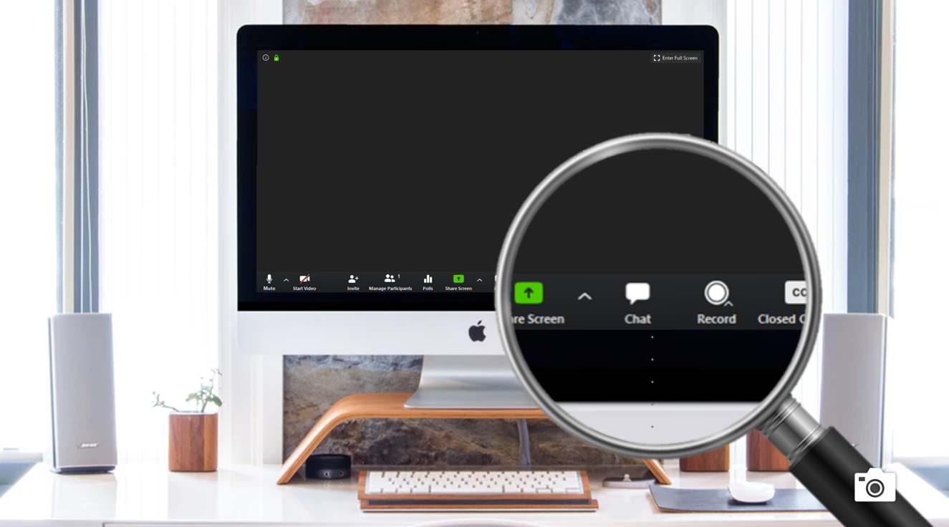 | Before we get started, I’d like to introduce myself. My name is _____________ (presenter name), and I’ll be your presenter today.  Our producer, and my fellow panelist, __________ (producer name), will be with us today as well and is here to help with any questions or technical assistance you may need. Say “hi,” ___________.  You’ll want to use the chat panel for … [Insert housekeeping items and/or platform use instructions]. | [Producer gives a brief greeting.]  Thanks (presenter name)!  Welcome everyone, we’re excited to have you joining us today!  My name is (producer name).
Blank Poll Template | 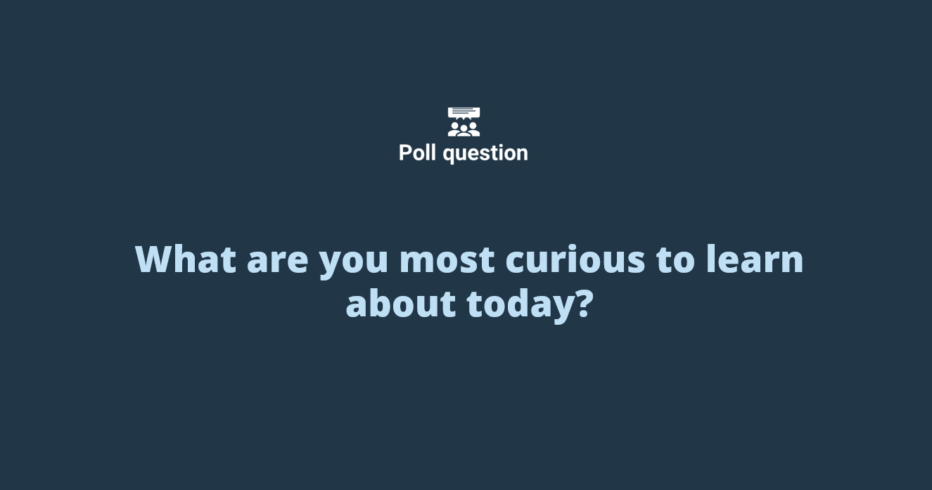 | [CALL OUT RESPONSES- “it looks like there’s a good mix/majority ___ here today”]  *replace the options in the question and answers* | [SELECT POLL# AND “Launch Poll ”]  Poll Question 1: What are you most curious to learn about, today?  - Option 1  - Option 2  - Option 3  - Option 4  [WHEN MAJORITY DONE: click End Poll, select ‘Share Results’.]  [Remove poll from view by clicking 'Stop Sharing’ at the bottom of the polling window.]
Q&A/ Close | 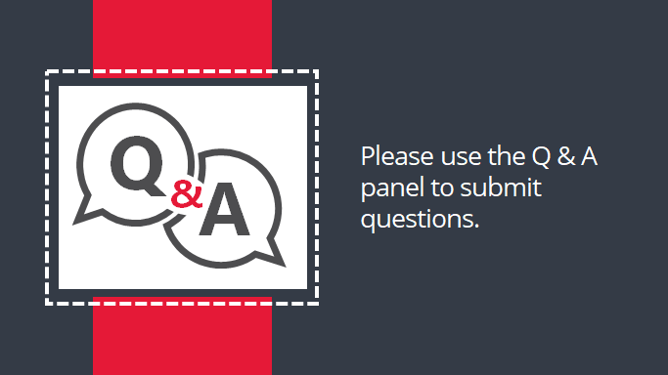 | For anyone who’d like to stick around we’ll be opening up now for questions! As a reminder, please use the Q&A panel for questions. We will do our best to answer your questions as quickly as possible and any questions that we don’t answer today we will reach out to you post webinar.  Thanks again, and have a great day!

